3/17/2019

Jesse Garcia

[company name]

Setup Sublime for Python

[Document subtitle]

Contents

1 Install Package Control 2

1.1 Reference 2

2 Install Packages 2

2.1 Install Predawn Scheme 2

2.2 Install Material Theme 3

2.3 Change Preferences/Settings 3

2.3.1 Original Preferences.sublime-settings--User settings 5

2.4 Install Package BracketHighlighter 5

2.5 Install Package SideBarEnhancements 5

2.6 Install Package Anaconda 5

2.6.1 Change Settings-User for Anaconda 5

Numbered Heading Template

# Install Package Control

Install Package Control.

Select Tools/Command Palette and enter “Install Package Control”

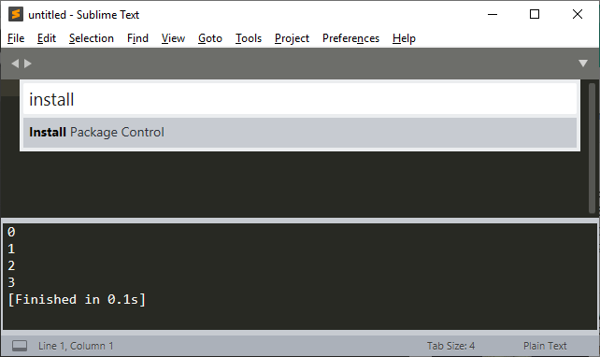

## Reference

https://www.youtube.com/watch?v=xFciV6Ew5r4

# Install Packages

Now is the time for all good men to come to the aid of their country.

Now is the time for all good men to come to the aid of their country.

## Install Predawn Scheme

Select Tools/Command Palette and enter “Install Package”, then select “Predawn”

## Install Material Theme

Select Tools/Command Palette and enter “Install Package”, then select “Material Theme”

Now is the time for all good men to come to the aid of their country.

## Change Preferences/Settings

Change “Preferences/Settings” for User by selecting Preferences/Settings

Overwrite all current settings in Preferences.sublime-settings—User with the following.

{

"theme": "Material-Theme-Darker.sublime-theme",

"color_scheme": "Packages/Predawn/predawn.tmTheme",

"material_theme_accent_graphite": true ,

"material_theme_compact_sidebar": true,

"file_exclude_patterns": ["*.pyc", "*.pyo", "*.exe", "*.dll", "*.obj","*.o", "*.a", "*.lib", "*.so", "*.dylib", "*.ncb", "*.sdf", "*.suo", "*.pdb", "*.idb", ".DS_Store", "*.class", "*.psd", "*.sublime-workspace"],

"font_face": "Source Code Pro",

"font_options":

[

"no_round"

],

"font_size": 20,

"bold_folder_labels": true,

"caret_extra_width": 1,

"caret_style": "phase",

"close_windows_when_empty": false,

"copy_with_empty_selection": false,

"drag_text": false,

"draw_minimap_border": true,

"enable_tab_scrolling": false,

"highlight_line": true,

"ignored_packages":

[

"Vintage"

],

"line_padding_bottom": 1,

"line_padding_top": 1,

"match_brackets_content": false,

"match_selection": false,

"match_tags": false,

"open_files_in_new_window": false,

"overlay_scroll_bars": "enabled",

"preview_on_click": false,

"scroll_past_end": true,

"scroll_speed": 5.0,

"show_full_path": false,

"sidebar_default": true,

"translate_tabs_to_spaces": true,

"trim_trailing_white_space_on_save": true,

"word_wrap": true,

"show_definitions": false,

"show_encoding": true,

"show_errors_inline": false,

"ensure_newline_at_eof_on_save": true,

"highlight_modified_tabs": true,

"use_simple_full_screen": true

}

### Original Preferences.sublime-settings--User settings

The original Preferences.sublime-settings--User settings were:

{

"ignored_packages":

[

"Vintage"

]

}

## Install Package BracketHighlighter

Select Tools/Command Palette and enter “Install Package”, then select “BracketHighlighter”

## Install Package SideBarEnhancements

Select Tools/Command Palette and enter “Install Package”, then select “SideBarEnhancements”

## Install Package Anaconda

This package provides specific items that supports Python in Sublime.

Select Tools/Command Palette and enter “Install Package”, then select “Anaconda”

NOTE: This is not Anaconda that provides data science support for Python.

### Change Settings-User for Anaconda

Select Preferences/Package Settings/Anaconda/Settings-User to the following

|  |
| --- |
| { |
|  |

|  |
| --- |
| "auto_formatting": true, |
|  |

|  |
| --- |
| "autoformat_ignore": |
|  |

|  |
| --- |
| [ |
|  |

|  |
| --- |
| "E309", |
|  |

|  |
| --- |
| "E501" |
|  |

|  |
| --- |
| ], |
|  |

|  |
| --- |
| "pep8_ignore": |
|  |

|  |
| --- |
| [ |
|  |

|  |
| --- |
| "E309", |
|  |

|  |
| --- |
| "E501" |
|  |

|  |
| --- |
| ], |
|  |

|  |
| --- |
| "anaconda_linter_underlines": false, |
|  |

|  |
| --- |
| "anaconda_linter_mark_style": "none", |
|  |

|  |
| --- |
| "display_signatures": false, |
|  |

|  |
| --- |
| "disable_anaconda_completion": true |
|  |

}